Enhancing Accessibility and Personalization in E-learning for Dyslexia Learners

R26-SE-031

Project Proposal Report
Gunasena R.K.R.M.S.K. – IT22125798

B.Sc. (Hons) Degree in Information Technology Specialized in
Software Engineering

Department of Information Technology

Sri Lanka Institute of Information Technology Sri Lanka

March 2025

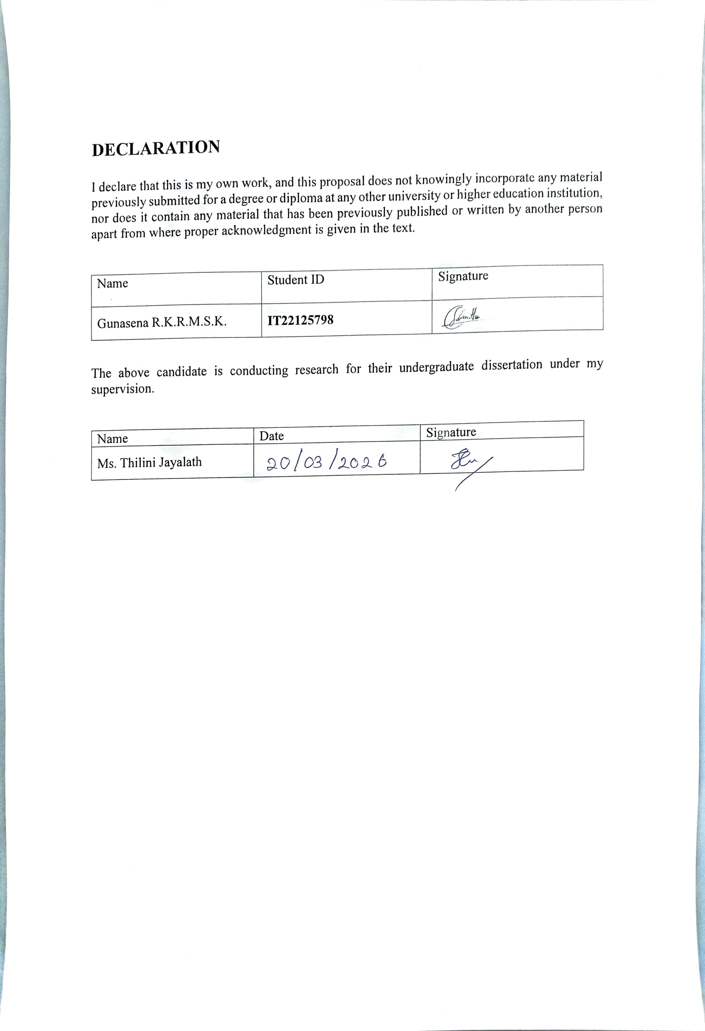

ABSTRACT
Reading literacy in early primary grades is a critical foundation for lifelong learning. Many Grade 1–2 Sinhala-medium children experience persistent decoding and fluency difficulties that go undetected or are identified late, in part because existing screening tools are language-biased, single-modality, or unsuitable for routine classroom use. Early, scalable detection is therefore essential to reduce long-term learning gaps and to direct limited instructional resources where they will have greatest impact.
This project addresses three linked gaps: the lack of field-validated, Sinhala-aware multimodal datasets for young learners; the absence of privacy-preserving, on-device monitoring engines that run within normal lessons on low-cost tablets; and the shortage of teacher-centered outputs that translate automated signals into concise, actionable classroom guidance. These gaps inhibit reliable early detection and downstream intervention in typical Sri Lankan classrooms.
We propose the Cognitive Learning Behavior Monitoring Engine (CLBME): a multimodal system that captures read-aloud audio, stylus pen traces and simple interaction logs during short curricular activities, extracts Sinhala-aware behavioral features (syllable pauses, letter-stroke deviations, hint/replay patterns), and fuses them into an interpretable per-task Learning Difficulty Index (LDI) and an at-risk classifier. The design emphasizes privacy-first on-device preprocessing, hybrid explainable models (lightweight sequence encoders + gradient-boosted trees), and a compact teacher dashboard that surfaces top contributing features and practical intervention suggestions co-designed with teachers.
Planned technologies include a cross-platform mobile front end, Python ML tooling, lightweight sequence models (LSTM/temporal CNN), gradient-boosted trees (LightGBM/XGBoost), model compression (quantization/pruning), and deployment via TensorFlow Lite or equivalent for Android tablets. Data collection targets N ≈ 200–400 Grade 1–2 students with clinician-validated subsamples, and evaluation metrics include sensitivity/specificity (primary goal: sensitivity ≥ 80%, specificity ≥ 75%), ROC-AUC, LDI MAE, within-session responsiveness (Cohen’s d), and teacher usability (SUS).
Expected outcomes are, an on-device prototype that produces interpretable LDI/at-risk flags, a validated multimodal dataset and annotation schema (governed release), teacher-facing guidance materials, and evidence of short-term pedagogical responsiveness. Social and commercial impacts include earlier and more equitable identification of reading difficulties, reduced remedial costs, stronger teacher capacity, and commercialization potential for scalable school and ministry deployments or EdTech partnerships.
Keywords: dyslexia screening, multimodal learning analytics, Sinhala literacy, on-device inference, HCL

ACKNOWLEDGEMENT
I would like to express our sincere gratitude to our research supervisor, Ms. Thilini Jayalath, for her continuous guidance, encouragement, and valuable insights throughout the development of this research proposal. Her expertise, constructive feedback, and support greatly contributed to shaping the direction and quality of this research work.
I also extend our heartfelt appreciation to our external supervisors, Ms. D. M. Dasunika Isurindi Dissanayake, Speech and Language Therapist and Visiting Lecturer at the Faculty of Medicine, University of Kelaniya, and Ms. Dinusha Fonseka, Speech and Language Therapist and Visiting Lecturer at the Faculty of Medicine, University of Kelaniya. Their professional knowledge and valuable advice regarding dyslexia and learning difficulties provided essential guidance for understanding the practical aspects of this research.
I would like to sincerely thank Ayati Trust Sri Lanka and the Ayati Centre, Faculty of Medicine, University of Kelaniya, for their support and for providing valuable opportunities to understand the challenges faced by children with dyslexia. The interaction with professionals and students associated with the center provided important insights that supported the development of this research project.
I am also grateful to Sri Lanka Institute of Information Technology (SLIIT) for providing the academic environment, resources, and technological support necessary to carry out this research work.
Finally, I would like to thank all individuals and organizations who supported us directly or indirectly in the successful preparation of this research proposal.

Table of Contents
1. INTRODUCTION 1
1.1 Background and Context 1
1.1.1 Real-world problem 2
1.1.2 Who is affected and why it is important 2
1.2 Literature Review 3
1.2.1 Sri Lanka specific empirical and policy studies 3
1.2.2 Technical research on automated dyslexia detection and monitoring 3
1.2.3 Existing products in Sri Lanka 4
1.2.4 Limitations of existing systems 5
1.3 Research Gap 6
1.3.1 What is missing 6
1.3.2 Why current approaches are insufficient 6
1.3.3 Justification of novelty and creativity 7
1.3.4 Evidence-based argument 7
2. OBJECTIVES 8
2.1 Main Objective 8
2.2 Specific Objectives 8
3. METHODOLOGY 9
3.1 Instrument and stimulus design 9
3.2 Ethical approvals & recruitment 9
3.3 Data collection & annotation 10
3.4 Feature engineering 10
3.5 Model development 11
3.6 Evaluation 11
3.7 Dissemination and impact evaluation 12
4. HIGH-LEVEL SYSTEM ARCHITECTURE 13
5. USER REQUIREMENTS 14
5.1 Stakeholder Identification 14
5.2 Functional Requirements (FR) 15
5.3 Non-Functional Requirements (NFR) 15
5.4 User Requirement Summary 16
6. COMMERCIALIZATION PLAN 17
6.1 Target Market and Customer Persona 17
6.2 Value Proposition 17
6.3 Revenue Model 17
6.3.1 Cost Estimation 18
7. BUDGET AND JUSTIFICATION 20
8. WORK BREAKDOWN STRUCTURE(WBS) 22
9. GANTT CHART 23
10. REFERENCES LIST 24

LIST OF TABLES
Table 1 - Pricing plan 17
Table 2 - Budgeting 20
Table 3 - Gantt chart 22

LIST OF FIGURES
Figure 1 - High-level system diagram 12
Figure 2 - Work Breakdown Structure 19

LIST OF ABBREVIATIONS
Abbreviation | Full Meaning
AI | Artificial Intelligence
DSR | Design Science Research
SDG | Sustainable Development Goal
SDG 4 | Sustainable Development Goal 4 – Quality Education
UI | User Interface
UX | User Experience
FR | Functional Requirement
NFR | Non-Functional Requirement
WBS | Work Breakdown Structure
API | Application Programming Interface
ML | Machine Learning
DB | Database
LKR | Sri Lankan Rupees
TTS | Text-to-Speech
HCI | Human Computer Interaction
EDM | Educational Data Mining
LMS | Learning Management System
CLBME | Cognitive Learning Behavior Monitoring Engine

INTRODUCTION

Background and Context
Reading literacy is one of the most fundamental skills developed during early primary education. It supports learning across subjects because most classroom activities require decoding print, extracting meaning from text, and expressing ideas in writing. A substantial number of children, however, experience persistent difficulties in acquiring reading skills due to neurodevelopmental differences commonly grouped under dyslexia. Dyslexia is characterized by inaccurate or effortful word reading, poor decoding and spelling, and weaknesses in phonological processing; these deficits occur despite adequate intelligence and access to instruction [1].
Early identification and timely intervention substantially improve literacy outcomes for children with dyslexia. When support begins during the initial years of schooling, many affected children can make meaningful gains and remain in mainstream classrooms. Conversely, late identification commonly results in accumulated skill gaps, reduced confidence, and poorer long-term outcomes [1], [4].
In Sri Lanka the problem has language- and system-specific dimensions. Sinhala is an alpha-syllabary with complex symbol shapes and many diacritic forms. Empirical studies with Sri Lankan samples show that knowledge of symbols, syllable awareness, rapid naming, and visual perceptual skills strongly predict word reading and fluency in Sinhala learners [2], [3]. Large-scale screening of Grade 1 and Grade 2 students in Sri Lanka demonstrates that many children enter school with low reading fluency, and that well-targeted early instruction and teacher training can substantially improve fluency by the end of Grade 2 [4]. Taken together, this evidence indicates that early reading problems in Sinhala are common, shaped by orthographic complexity, and responsive to early detection and instructional support [2], [3], [4].
This project focuses on Grade 1 and Grade 2 Sinhala-medium pupils in Sri Lanka. The proposed Cognitive Learning Behavior Monitoring Engine (Component 1) is designed to capture natural reading behaviors (speech, handwriting/trace, and touch interactions) during routine app activities, convert these signals into interpretable features and time-series indices, and produce a Reading Strain Index (RSI) that can serve as a practical screening and monitoring signal for teachers and caregivers. The design and evaluation will be informed by Sri Lankan studies on symbols learning, early screening tools developed for Sinhala, and local teacher knowledge gaps [2], [3], [5], [6].

Real-world problem
Sri Lanka lacks a comprehensive, scalable system to detect and monitor reading difficulties in early primary grades. Although research and small-scale screening tools exist, routine systematic screening in government primary schools is limited, and many teachers report low confidence and limited training in identifying dyslexia-related signs [5]. Consequently, children with early reading difficulties may not receive timely support. The absence of language-appropriate, low-cost screening and monitoring solutions increases the risk that students will fall behind during the critical Grade 1–2 period.

Who is affected and why it is important
Primary beneficiaries are Grade 1 and Grade 2 Sinhala-medium students and the professionals and caregivers who support them. International estimates show that a non-trivial proportion of school-aged children display dyslexia-related difficulties; local Sri Lankan evidence confirms language-specific risk factors and identifies many children with weak symbols knowledge and low reading fluency in early grades [1], [2], [3], [4]. Teachers and schools’ benefit because earlier detection lowers long-term remedial cost, improves retention, and enables targeted classroom support. Families gain clear, actionable indicators to support home learning. From a system viewpoint, better early identification supports equitable learning outcomes and reduces downstream special-education burden.

Literature Review
The literature informing this project falls into three related domains: (A) Sri Lanka-specific empirical and policy studies on dyslexia, teacher readiness and Sinhala literacy; (B) technical work on automated dyslexia screening and monitoring (multimodal AI); and (C) practical tools and prototypes developed for Sinhala. The review emphasizes Sri Lankan evidence and then summarizes relevant global technical findings when they clarify algorithmic choices or show limitations that affect deployment.

Sri Lanka specific empirical and policy studies
A national survey of 705 Sri Lankan primary teachers reported pervasive gaps in teacher knowledge, confidence and access to screening tools for dyslexia; the authors recommended targeted teacher training and context-appropriate screening instruments for Sri Lanka [1]. A clinical and educational overview of dyslexia in Sri Lanka similarly documents limited national prevalence data, constrained clinical resources, and low teacher awareness, and it calls for locally adapted identification and intervention approaches [2]. These syntheses indicate a clear need for low-cost, language-appropriate screening and monitoring solutions.
Empirical studies of early Sinhala literacy identify language-specific risk factors that are essential when designing screening features. A cross-sectional study of symbols knowledge among Grades 1 and 2 children in the Gampaha District describes developmental patterns in symbol knowledge and syllable processing that predict early reading outcomes in Sinhala learners [3]. University research groups in Sri Lanka have produced additional local data and tools for early literacy detection and 'red flag' screening for Sinhala, reinforcing the need for instruments tuned to symbols-level errors, syllable segmentation, and diacritic handling [4], [5]. Collectively, the Sri Lankan work shows that teachers want practical tools but often lack training, that Sinhala orthography produces specific decoding errors, and that local pilot prototypes are feasible but require larger samples and field validation.

Technical research on automated dyslexia detection and monitoring
Automated dyslexia detection research has progressed rapidly. Reviews and recent studies show three important points relevant to Component 1: (a) multimodal fusion improves detection robustness, (b) low-cost sensing modalities (audio and tablet pen data) are practical for classroom deployment, and (c) model explainability and dataset diversity remain major challenges [6], [7].
Multimodal fusion that combines handwriting, speech and (where available) gaze or oculomotor measures tends to outperform single-modality methods because each signal captures complementary cognitive or sensorimotor markers of reading difficulty. Recent multimodal frameworks demonstrate that integrating speech-derived fluency measures with pen-stroke features and simple eye metrics increases classification accuracy and provides richer behavioral profiles [8], [9]. However, many multimodal studies rely on lab-grade sensors or small homogeneous datasets; this limits generalizability to diverse classroom contexts [6], [10].
Eye-tracking research consistently reports discriminative oculomotor markers (longer fixation durations, more regressions, altered saccades) in dyslexic readers, and machine learning on eye metrics can yield strong classification performance in controlled settings [11]. The practical problem is cost and logistics: high-quality eye trackers are expensive and not scalable in many Sri Lankan classrooms. Recent work therefore emphasizes low-cost alternatives (webcam-based gaze approximations) or the priority of audio and pen stroke features for field deployment [8], [12].
Handwriting and pen-trace analysis yields robust, low-cost features (stroke velocity, curvature, pen-lift frequency) that correlate with writing fluency and fine motor control. Tablet-based collection of stylus traces has been shown to support automated detection of dysgraphia and related writing difficulties with good accuracy in research datasets [13], [14]. Similarly, speech-based read-aloud analysis (silent pause counts, articulation rate, ASR-derived error patterns or phoneme proxies) is attractive because mobile devices already provide adequate audio capture; several studies report useful screening signals from simple acoustic and timing features [15], [16].
Systematic reviews emphasize practical cautions: dataset bias (languages and dialects under-represented), lack of interpretability in deep models, and insufficient field validation in low-resource school settings [6], [7]. For our project this implies prioritizing language-specific feature design, interpretable models (for teacher trust), and careful field data collection among Grade 1–2 Sinhala learners.

Existing products in Sri Lanka
Local innovation in Sri Lanka demonstrates feasibility. The ARUNALU multisensory learning ecosystem (SLIIT) is a notable Sinhala-focused effort combining voice recognition, phonological support and prototype screening modules; it shows that machine-assisted Sinhala tools can be built locally, but published evidence remains at demonstration or pilot stage and lacks large-scale validation [5]. Other university projects and small pilots have produced reading stimuli, teacher resources and early screening modules; however, most lack an integrated, validated monitoring engine that produces continuous, interpretable difficulty indices for classroom teachers.
International products exist for dyslexia screening and support, but they mainly target English or other Latin-based orthographies and often depend on special hardware or proprietary datasets. These differences limit direct transfer to Sinhala contexts without language- and script-specific adaptation.
International products exist for dyslexia screening and support, but they mainly target English or other Latin-based orthographies and often depend on special hardware or proprietary datasets. These differences limit direct transfer to Sinhala contexts without language- and script-specific adaptation.

Limitations of existing systems
The literature identifies recurring limitations that motivate Component 1 :
- Language bias and dataset scarcity. Most ML models are trained on English or Western-language corpora. Sinhala-specific corpora, grapheme–phoneme maps and aligned child speech datasets are rare, reducing direct transferability of models and features [2], [3], [6].
- Hardware and contextual mismatch. Lab-grade measurements (high-resolution eye trackers, clinical assessments) produce high accuracy but are often impractical in under-resourced classrooms. Low-cost mobile sensors (microphone, tablet stylus) are more scalable but require careful preprocessing for noisy conditions [8], [11], [13].
- Point-in-time diagnosis vs continuous monitoring. Many screening tools are one-off tests. The literature suggests continuous, in-lesson monitoring better captures moment-to-moment difficulty, supports adaptive instruction, and reduces testing burden; yet few deployed systems implement robust continuous monitoring in low-resource languages [6], [9].
- Explainability and teacher usability. Black-box models provide little practical guidance for teachers. Studies and teacher surveys from Sri Lanka emphasize that outputs must be interpretable, actionable and closely tied to classroom practices to be adopted at scale [1], [5].
These findings directly inform the design choices for Component 1: prioritize Sinhala-specific features (symbols and syllable metrics), use low-cost modalities (audio + pen + UI events), prefer interpretable or hybrid models for RSI scoring, and plan field validation with Grade 1–2 school samples and teacher feedback.

Research Gap

What is missing
Despite useful local studies and promising prototypes, four evidence-backed gaps remain for Sinhala language focused, primary school students.
- Field-validated, Sinhala multimodal datasets. There is no large-scale, Sri Lanka-specific dataset that combines read-aloud audio, pen-trace (stylus) trajectories, and time-stamped interaction logs collected from Grade 1–2 learners across diverse school contexts. Existing Sinhala data are either small, modality-limited, or at pilot scale; most large datasets used in automated screening are English-centric and do not capture Sinhala symbols-level errors or local dialect variation [1], [2], [3].
- On-device, low-cost monitoring engines validated in classrooms. Current research and many prototypes demonstrate algorithmic feasibility, but few systems provide a privacy first, lightweight on-device monitor that computes interpretable, per-task difficulty indices during ordinary lessons on affordable tablets. Sri Lankan prototypes (for example ARUNALU) show promise but lack published large-scale validation in real classroom deployments [4], [5].
- Teacher-integrated, actionable outputs. There is limited work that translates automated screening signals into concise, actionable guidance that fits Sri Lankan primary classroom workflows. Teacher surveys and national studies report limited confidence and time to adopt complex or opaque outputs; pragmatic, prioritized recommendations are required for uptake [1], [11].
- Validated language-aware features and evaluation protocols. Sinhala orthography (symbols-based script and diacritic behavior) requires feature extractors tuned to syllable and grapheme properties; global feature sets and phoneme mappings do not transfer directly. There is a need for validated evaluation protocols and clinical concordance metrics (sensitivity, specificity, MAE for RSI) derived from representative Grade 1–2 samples [2], [3], [6].

Why current approaches are insufficient
Current global AI approaches frequently assume abundant language-specific training data, homogeneous recording conditions, or access to special hardware (high-end eye trackers, clinical labs). These assumptions do not hold in most Sri Lankan primary classrooms. Conversely, Sri Lankan educational research documents teacher readiness issues, orthographic specificities, and small-scale pilots, but few studies deliver a validated, scalable monitoring system that (a) runs within normal lessons, (b) uses only affordable mobile sensors, and (c) produces interpretable outputs that teachers can act on [1], [2], [4], [5]. Therefore, neither existing global technical solutions nor current local research alone solve the combined technical, linguistic and operational problem required for scalable early identification in Sri Lanka.

Justification of novelty and creativity
- Language-aware multimodal features. Feature extractors will be explicitly designed for Sinhala symbols and syllabic phonology (for example, syllable-level pause metrics, diacritic-aware grapheme error proxies, and symbols-template stroke deviation). This linguistic grounding increases ecological validity and predictive power compared with models ported from English [2], [3].
- In-lesson, on-device monitoring with privacy-by-design. CLBME computes interpretable indices (Reading Strain Index, RSI) on affordable tablets during ordinary learning interactions. On-device preprocessing reduces privacy risk and bandwidth needs, and enables continuous monitoring rather than point-in-time tests [4], [6].
- Teacher-centered explainability and workflows. CLBME provides concise, ranked feature attributions and recommended classroom actions (for example, targeted phonics drills, extra syllable segmentation tasks). These outputs will be co-designed with teachers and validated for clarity and feasibility, increasing the likelihood of classroom adoption [1], [11].

Global systematic reviews demonstrate the technical feasibility of multimodal detection and the added value of combining handwriting, speech, and eye-movement signals for classification accuracy and robustness. However, Sri Lankan needs documented in teacher surveys and local literacy studies show that a locally tailored, low-cost, explainable system is required to translate technical capability into classroom impact. Bridging these two bodies of evidence—by constructing Sinhala-aware feature sets, validating models on representative Sri Lankan Grade 1–2 data, and embedding outputs into teacher workflows—constitutes the core scientific and practical contribution of this proposal.

Evidence-based argument
Two strands of evidence support the proposed approach. First, global systematic reviews and recent multimodal studies demonstrate that combining handwriting, speech and simple gaze proxies improves detection robustness and classification performance in research settings [5], [6], [7]. Second, Sri Lanka-specific studies and teacher surveys document the orthographic characteristics of Sinhala (symbols complexity), local literacy patterns in Grade 1–2, and the pressing need for teacher-ready screening tools [1], [2], [3], [4]. Bridging these strands requires (a) constructing Sinhala-aware multimodal feature sets, (b) collecting representative Grade 1–2 data across school types, and (c) embedding interpretable RSI outputs into teacher workflows. Implementing and validating this pipeline in Sri Lankan classrooms constitutes both the core scientific contribution and the practical innovation of the proposal.

OBJECTIVES

Main Objective
To design, implement, and validate a Cognitive Learning Behaviour Monitoring Engine (CLBME) that provides accurate, interpretable and classroom-usable detection of early reading difficulties among Grade 1–2 Sinhala-medium students in Sri Lanka, thereby enabling timely, evidence-based instructional responses for teachers and caregivers.
Quantitative success criteria (primary):
- At-risk classifier sensitivity ≥ 80% and specificity ≥ 75% on a held-out Sri Lankan Grade 1–2 test set, where labels are clinician/teacher consensus.
- Reading Difficulty Index (LDI) regression MAE ≤ 8 (on a 0–100 scale) vs clinician-rated task difficulty.
- On-device inference latency ≤ 5 seconds per task on target affordable Android tablets (typical CPU + 2 GB RAM).

Specific Objectives
Feature identification. Identify and operationalize a set of Sinhala-aware behavioral features (audio, stylus/pen trace, UI interactions) that correlate with early decoding and fluency difficulties in Grade 1–2 learners, guided by local akshara studies and teacher input [2], [3].
Dataset creation. Collect and curate a multimodal dataset of N ≈ 200–400 Grade 1–2 students across diverse Sri Lankan schools (urban/rural; public/private), including teacher screening labels for all participants and clinician-validated diagnostic assessments for an N ≈ 50 subsample.
Model development. Develop lightweight, explainable machine learning models (for example, gradient-boosted trees fused with small sequence encoders) that produce a per-task Learning Difficulty Index (LDI; 0–100) and a binary at-risk prediction. Prioritize interpretability (feature importance, top-3 contributors).
On-device prototype. Implement and optimize CLBME for affordable Android tablets using model compression (quantization, pruning, distillation) and privacy-first defaults (raw media retained locally; only aggregated features uploaded with consent).
Evaluation. Evaluate diagnostic performance (sensitivity, specificity, ROC-AUC), responsiveness to in-lesson adaptive UI changes (effect size: Cohen's d), modal contribution (ablation), and teacher usability (SUS + qualitative interviews).

METHODOLOGY
This project follows a Design Science Research (DSR) approach combined with empirical field validation in schools [7]. Research activities run in five parallel tracks: (A) instrument and stimulus design; (B) ethics and site recruitment; (C) data collection and annotation; (D) model development and on-device engineering; (E) evaluation and teacher co-design.

Instrument and stimulus design
Task battery. Design short, age-appropriate tasks to fit Grade 1–2 attention spans (total session 10–15 minutes):
- Read-aloud passages (30–90 seconds each), graded by lexical and syllable complexity.
- Syllable/word segmentation mini games (clap/drag tasks).
- Pen-trace templates for symbol/letter tracing (three graded difficulty levels).
Passages and stimuli will be aligned to national Grade 1–2 curricula and piloted with local teachers.
Measurement specifications.
- Audio: 16 kHz, mono; on-device Voice Activity Detection (VAD); brief read-aloud prompts.
- Stylus/pen traces: capture (x, y, t) and pressure (if available); sampling at device rate.
- UI events: timestamped taps, hints requested, replays, and correction attempts.
- Metadata: age, grade, first language, medium of instruction, school type, and device model.

Ethical approvals & recruitment
- Obtain institutional ethics approval and parental informed consent, child assent for sessions.
- Recruit a stratified sample across 6–10 schools (public and private; urban and rural) to ensure demographic and dialectal diversity and to reduce site bias in modeling.

Data collection & annotation
Field protocol. 10 to15-minute sessions per child administered by trained research assistants or participating teachers in a familiar classroom setting to preserve ecological validity. Recordings and traces remain on device by default; upload only aggregated/anonymized features with explicit consent.
Labeling strategy
- Teacher screening checklist (binary at-risk / not-at-risk) for all participants.
- Clinician diagnostic assessment (gold standard) for an N ≈ 50 subsample selected to represent the full difficulty spectrum. Clinician labels form the primary ground truth for diagnostic metrics.
Quality control
Periodic calibration visits, inter-rater reliability checks for teacher labels, and automated sanity filters for noisy audio or corrupted trace files.

Feature engineering
Audio features (Sinhala-aware): syllable segmentation, pause counts and durations, articulation rate (syllables/sec), prosodic rhythm measures, ASR-proxy mismatch counts using a lightweight Sinhala wordlist or lexicon-matching approach. Features explicitly handle akshara-related phonological error patterns [2], [3].
Pen-trace/on screen drawing features: stroke velocity mean/variance, curvature deviation from canonical akshara stroke templates, pen-lift frequency and duration, trace completion time, and temporal stroke sequencing metrics.
Interaction features: hint rate, replay frequency, time-on-task, error-correction patterns, repeated-word counts.
Composite indices: compute a per-task Learning Difficulty Index (LDI; 0–100) from a weighted fusion of sub-scores (decoding, fluency, motor stability). Weighting initially derived from clinician importance ratings and refined via model explainability (feature attributions).

Model development
Architecture (two-stage fusion):
- Sequence encoder (small LSTM or temporal CNN) to model within-task temporal dynamics of audio and pen-trace streams.
- Feature fusion & decision stage using gradient-boosted trees (LightGBM/XGBoost) for final LDI regression and binary risk classification. This hybrid design preserves interpretability (tree-based importance) while modeling temporal structures.
Training regimen: stratified cross-validation with school-level folds to reduce site bias. Address class imbalance with cost-sensitive loss functions and targeted augmentation (simulated pauses, time-warping for traces) where appropriate.
Explainability: use tree-based attributions (feature importance) and SHAP explanations to produce compact, teacher-friendly explanations (for example, top-3 contributing features for high LDI) [8].
On-device optimization: apply quantization, pruning and possible knowledge distillation (for example, to TensorFlow Lite) to meet latency and memory constraints. Measure latency on representative target devices and iterate until inference ≤ 5 s.

Evaluation
Diagnostic performance: sensitivity, specificity, ROC-AUC vs clinician/teacher labels on a held-out test set. Primary targets: sensitivity ≥ 80%, specificity ≥ 75%.
LDI accuracy: MAE and concordance correlation with clinician-rated task difficulty.
Responsiveness (pedagogical effect): within-session A/B testing of adaptive visual supports (for example, syllable highlighting, spacing adjustments). Measure immediate LDI change and compute Cohen's d for effect size.
Modal contribution: systematic ablation (audio-only, handwriting-only, multimodal) to quantify incremental value of each modality.

Dissemination and impact evaluation
- Share anonymized aggregated feature sets and annotation schemas under controlled governance to enable replication and local research.
- Produce practitioner outputs: teacher guides, short training videos, and a lightweight dashboard prototype.
- Plan a follow-up pilot evaluation (optional) to measure educational impact: reading fluency gains over a semester among students flagged as at-risk and provided targeted interventions.

HIGH-LEVEL SYSTEM ARCHITECTURE
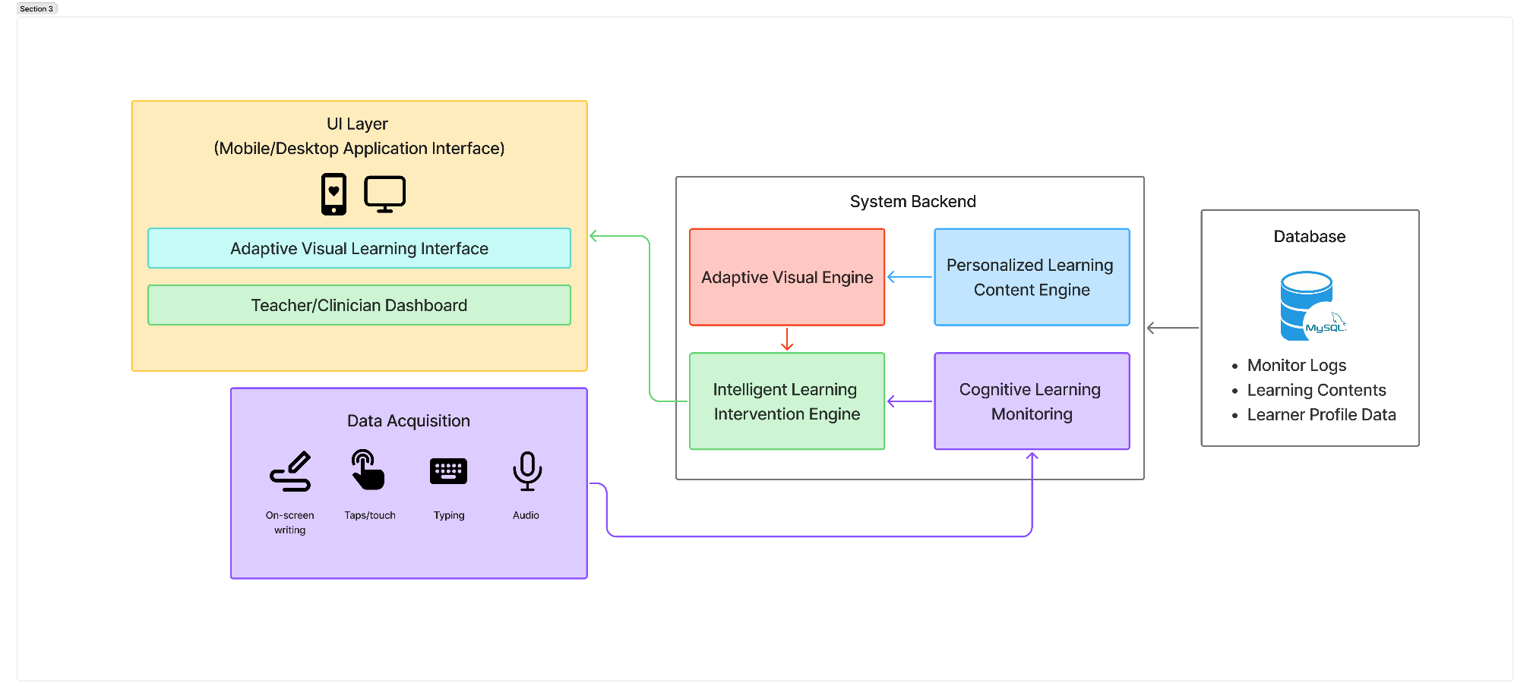
Figure 1 - High-level system diagram

USER REQUIREMENTS
The Cognitive Learning Behavior Monitoring Engine (CLBME) is designed as part of an educational support system that assists early identification and monitoring of reading difficulties among Grade 1 and Grade 2 Sinhala medium students in Sri Lanka. The system interacts with multiple stakeholder groups including students, teachers, caregivers, and system administrators. Understanding the needs of these users is essential to ensure that the system is practical, accessible, and effective in classroom environments.
The user requirements were derived from three main sources: (1) findings from Sri Lankan dyslexia research and teacher readiness studies, (2) consultation with speech and language therapists and educators, including professionals affiliated with the Ayati Centre, and (3) analysis of existing digital learning systems and accessibility guidelines. These requirements guide the design of system features, interaction flows, and data processing components.

Stakeholder Identification
The main user groups of the system are summarized below:
- Primary users - Students (Grade 1–2).
Young Sinhala medium learners who interact with the learning activities within the mobile application. Their interactions generate behavioral signals such as speech recordings, handwriting traces, and interaction patterns used by the CLBME to estimate learning difficulty.
- Secondary users - Teachers.
Primary school teachers who require clear indicators of student reading difficulty and actionable recommendations to support classroom instruction.
- Supporting users - Caregivers/Parents.
Parents or guardians who wish to monitor their child’s reading progress and follow recommended practice activities at home.
- System administrators and researchers.
Technical staff responsible for system configuration, data management, model updates, and maintenance.

Functional Requirements (FR)
Functional requirements describe the core features that the system must provide in order to achieve its objectives.
FR1 – Student Interaction Module
The system shall provide an interactive learning interface where Grade 1–2 students can complete reading, pronunciation, and tracing activities aligned with the national curriculum.
FR2 – Speech Recording and Processing
The system shall capture student read-aloud audio during reading activities and process it to extract behavioral features such as pause duration, articulation rate, and pronunciation patterns.
FR3 – Handwritten Trace Capture
The system shall record stylus or touchscreen drawing traces when students perform letter or word tracing tasks, including coordinates, time stamps, and stroke characteristics.
FR4 – Reading Strain Index (RSI) Calculation
The system should compute a Reading Strain Index using multimodal behavioral features collected during tasks. This index will represent the relative level of reading difficulty observed for a learner.
FR5 – Early Risk Screening
The system shall classify whether a learner may be at risk of reading difficulty based on RSI thresholds and machine learning model outputs.

Non-Functional Requirements (NFR)
Non-functional requirements define the quality attributes that ensure the system is usable, reliable, and appropriate for school environments.
NFR1 – Usability
The system interface must be simple and intuitive for young learners aged 6–7. Activities should include clear visual cues, minimal text instructions, and engaging graphics.
NFR2 – Accessibility
The system must support learners with reading difficulties by including accessibility features such as audio instructions, text highlighting, and adjustable font sizes.
NFR3 – Performance
The CLBME must compute RSI scores and provide feedback within 5 seconds after completion of a learning activity to maintain classroom workflow efficiency.

NFR4 – Privacy and Data Protection
All student data must be handled in accordance with ethical research standards. Personal identifiers should be anonymized, and audio or trace data should remain stored locally unless explicit consent is provided.
NFR5 – Scalability
The architecture should allow the system to support multiple schools and hundreds of students without significant performance degradation.
NFR6 – Maintainability
The system must use modular software components so that individual modules (data processing, model inference, user interface) can be updated independently.

User Requirement Summary
The user requirements highlight the need for a simple, accessible, and teacher-friendly system that can operate effectively in real Sri Lankan classroom environments. Students require engaging learning activities that naturally capture behavioral signals, while teachers require clear and interpretable insights that support instructional decisions. Caregivers benefit from simplified progress monitoring that enables continued practice at home.
By integrating these functional and non-functional requirements, the CLBME system aims to provide a practical and scalable solution for early detection and monitoring of reading difficulties among Sinhala primary school learners.

COMMERCIALIZATION PLAN

Target Market and Customer Persona
The primary target market for the proposed system includes primary schools, special education centers, and parents of children with dyslexia in Sri Lanka. Many schools and parents seek accessible digital learning tools that support children experiencing reading difficulties.
The system is particularly designed for primary school students aged 6–12 years who require additional reading support. Educational institutions can use the platform as a supplementary learning tool to help students improve reading fluency and comprehension.
A typical customer persona includes primary school teachers, special education instructors, and parents who are looking for an effective digital platform that provides personalized literacy exercises and structured reading support for children with dyslexia.

Value Proposition
The proposed system provides a personalized mobile learning environment specifically designed for students with dyslexia. The platform combines adaptive learning techniques, personalized content selection, and dyslexia-friendly visual presentation to improve reading accessibility and engagement.
By analyzing learner interaction data, the system continuously adapts reading materials and learning activities according to the learner’s performance and reading ability. This approach allows students to practice reading at an appropriate difficulty level while gradually improving literacy skills.

Revenue Model
The system can adopt a subscription-based revenue model where schools or parents subscribe to the platform to access personalized learning features.
Possible revenue streams include:
- Individual user subscriptions for parents who want to support their children’s reading development at home.
- School licensing packages allow multiple students to access the system within an educational institution.
- Premium educational content packages that provide additional literacy exercises and learning activities.
This model allows the platform to generate sustainable revenue while maintaining accessibility for educational users.

Cost Estimation
The main costs involved in developing and maintaining the system include:
System Development Costs
Costs related to mobile application development, system design, and implementation of adaptive learning functionalities.
Educational Content Development
Creation of Sinhala reading materials, literacy exercises, and curriculum-aligned educational content.
Cloud Infrastructure Costs
Expenses related to database storage, server hosting, and cloud services used to store learning data and system resources.
Maintenance and Updates
Ongoing system improvements, bug fixes, and updates required to maintain system performance and reliability.
Pricing Strategy
The pricing strategy is designed to ensure affordability for Sri Lankan schools and families.
Plan Type | Target Users | Price Range | Features
Individual Student Plan | Individual students / parents | LKR 500 – LKR 700 per month | Access to personalized learning features and reading exercises
School Plan | Schools and educational institutions | LKR 25,000 – LKR 40,000 per year | Institutional access for multiple students and teachers
Free Basic Version | General users | Free | Limited reading exercises with basic learning features
Table 1 - Pricing plan

Competitive Advantage
The proposed system offers several advantages compared to general digital learning applications:
- Focused support for dyslexic learners rather than general learning platforms.
- Personalized learning content selection based on learner performance.
- Adaptive visual reading interface designed to improve readability for students with dyslexia.
- Mobile-based learning accessibility, allowing students to practice reading anytime and anywhere.
- Content designed specifically for the Sri Lankan primary education context.
These features enable the platform to provide more targeted and effective reading support for students with dyslexia.

BUDGET AND JUSTIFICATION
No. | Budget Item | Unit Cost (LKR) | Qty | Total (LKR) | Justification
Software Licenses
1 | Python 3.10 + scikit-learn + FastAPI + Redis | Free | — | — | All open-source zero cost. Core ML and API stack for Components 1, 3, and 4 classifiers, REST endpoints, and WebSocket server.
2 | React + Tailwind CSS + Recharts + HTML5 Canvas API | Free | — | — | Open-source front-end stack for Component 2 adaptive UI and Component 4 intervention activities. No licensing fee.
3 | gTTS (Google Text-to-Speech) | Free | — | — | Free Python library. Supports Sinhala (si) and Tamil (ta) locales. Used in Component 4 for syllable audio and Template Song generation. Offline after first run.
4 | PostgreSQL — learner model and content database | Free | — | — | Open-source relational database. Stores BKT mastery, SM-2 schedules, intervention history, RSI logs, and content metadata across all components.
5 | GitHub Education Pack — version control and CI/CD | Free | — | — | Free for SLIIT students. Covers all four component repositories, Actions CI/CD pipelines, and private team collaboration.
6 | Figma — UI wireframes and usability prototypes | Free | — | — | Free student tier. Used for Component 2 visual template design and caregiver/teacher usability testing prototypes.
Cloud Services
7 | Oracle Cloud Free Tier — app hosting and PostgreSQL | Free | — | — | Always-Free tier provides 2 AMD VMs and 20 GB storage — sufficient for all four component microservices at research and pilot scale.
8 | Redis Cloud Free Tier — RSI event pub-sub streaming | Free | — | — | 30 MB free Redis instance sufficient for real-time RSI streaming between Component 1 and Components 2, 3, and 4 during pilot sessions.
9 | Internet charges — development and pilot study (6 months) | 400 | 6 | 2,400 | LKR 400/month Sri Lanka mobile data plan (~15 GB/month). Covers model downloads, package installs, gTTS API calls, and optional dashboard synchronization.
Human Effort Costs
10 | Inclusive education specialist — exercise bank review | 3,000 | 1 | 3,000 | One-time review of Component 3 phonological drill bank and Component 4 multisensory activity design for clinical appropriateness and alignment with DSM-5 and ICD-11 dyslexia intervention principles.
11 | Song and poem authoring or copyright clearance | 2,000 | 1 | 2,000 | Commission culturally appropriate Sinhala and Tamil songs and rhymes for Component 4 Template Song activity or obtain rights clearance. Content mapped to NIE phonological targets for Grade 1 and Grade 2.
12 | NIE curriculum material sourcing and digitization | 2,000 | 1 | 2,000 | Legal procurement, scanning, and digitization of Grade 1–3 Sinhala and Tamil NIE curriculum materials for Component 3 content mapping ontology and Component 4-word difficulty dataset construction.
13 | Ethics consent form printing (English, Sinhala, Tamil) | 30 | 160 | 4,800 | 160 pages: consent and participant information sheets for 20 pilot families across three languages, plus school administrator copies. LKR 30 per page standard Sri Lankan print-shop rate.
14 | Travel to partner schools — all field visits | 950 | 20 | 19,000 | LKR 950 per return visit (bus or tuk-tuk). Component 1 data collection: 6 visits. Component 2 usability testing: 4 visits. Component 4 pilot study, ethics submission, and close-out: 10 visits. Total: 20 visits across the project.
15 | Participant refreshments — pilot study sessions | 250 | 20 | 5,000 | LKR 250 per child per session for snacks and drinks. The best ethical practice for research involving children builds rapport and reduces attrition across Component 1 and Component 4 sessions.
16 | Stationery, printed forms and field notebooks | 2,500 | 1 | 2,500 | Session observation checklists, researcher field notes, and annotation worksheets used across all four components during data collection and the pilot study.
17 | Contingency reserve (10% of direct cash costs) | — | — | 5,670 | Reserve for unexpected travel, reprinting, additional reviewer sessions, or minor unforeseen needs. Applied only to direct cash outgoings — not to zero-cost tools or free hosting services.
TOTAL ESTIMATED BUDGET (LKR) |  |  |  |  | 62,370
Table 2 - Budgeting

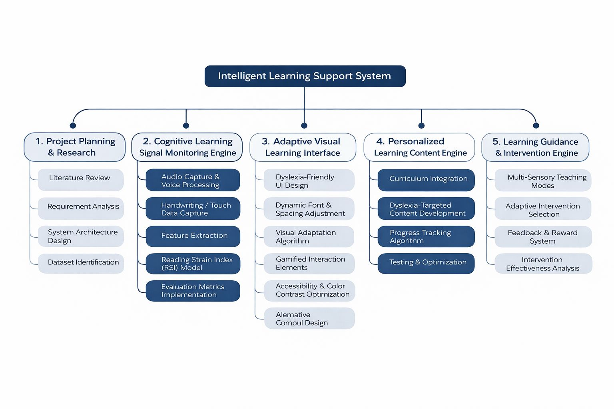
WORK BREAKDOWN STRUCTURE(WBS)
Figure 2 - Work Breakdown Structure

GANTT CHART
Phases | March | April |  |  | May |  |  | Jun | Jul | Aug | Sep | Oct | Nov | Dec
Proposal
Design Wireframes & Prototype
Data Collection
Backend Implementation
Data Processing
Model Development
Check List Submission
Progress Presentation 1
Final Check List Submission
Progress Presentation 2
Final Documentation
Website Submission
Final Presentation
Table 3 - Gantt chart

REFERENCES LIST
[1] W. A. Nadhee N. Peries, B. Indrarathne, B. D. W. Jayamanne, T. D. Wickramasekara, K. A. C. Alwis, and A. U. Jayatilleke, “Primary school teachers' readiness in identifying children with dyslexia: A national survey in Sri Lanka,” Dyslexia, vol. 27, no. 4, pp. 486–509, Nov. 2021, doi: 10.1002/dys.1696. Available: https://doi.org/10.1002/dys.1696

[2] D. Hettiarachchi, “An overview of dyslexia,” Sri Lanka Journal of Child Health, vol. 50, no. 3, pp. 529–534, 2021, doi: 10.4038/sljch.v50i3.9741. Available: https://doi.org/10.4038/sljch.v50i3.9741

[3] M. A. D. K. Wijaythilake, R. Parrila, T. Inoue, et al., “Cognitive predictors of word reading in Sinhala,” Reading and Writing, vol. 32, no. 7, pp. 1881–1907, 2019, doi: 10.1007/s11145-018-9927-5. Available: https://doi.org/10.1007/s11145-018-9927-5

[4] P. Cooper and M. Jukes, “End-of-Grade-2 Evaluation Report,” Room to Read, Jan. 19, 2016. Available: https://www.roomtoread.org/media/hjppn5wt/2014-2015-lk-sinhala-end-of-grade-2-evaluation-technical-report.pdf

[6] Y. Alkhurayyif and A. R. W. Sait, “A Review of Artificial Intelligence-Based Dyslexia Detection Techniques,” Diagnostics, vol. 14, no. 21, art. no. 2362, 2024, doi: 10.3390/diagnostics14212362. Available: https://doi.org/10.3390/diagnostics14212362

[7] E. I. Toki, “Using Eye-Tracking to Assess Dyslexia: A Systematic Review of Emerging Evidence,” Educational Sciences, vol. 14, no. 11, art. no. 1256, 2024, doi: 10.3390/educsci14111256. Available: https://doi.org/10.3390/educsci14111256

[11] L. Rello and M. Ballesteros, “Detecting readers with dyslexia using machine learning with eye tracking measures,” in Proc. 12th Web for All Conf. (W4A ’15), 2015, Art. no. 16, pp. 1–8, doi: 10.1145/2745555.2746644. Available: https://doi.org/10.1145/2745555.2746644

[13] P. Drotár and M. Dobeš, “Dysgraphia detection through machine learning,” Scientific Reports, vol. 10, art. no. 21541, 2020, doi: 10.1038/s41598-020-78611-9. Available: https://doi.org/10.1038/s41598-020-78611-9

[15] F. Ribeiro, A. Pereira Jr., D. Paiva, L. Alves, and A. Bianchi, “Early Dyslexia Evidences using Speech Features,” in Proc. 22nd Int. Conf. on Enterprise Information Systems (ICEIS 2020), vol. 1, pp. 640–647, 2020, doi: 10.5220/0009574906400647. Available: https://doi.org/10.5220/0009574906400647

[16] A. JothiPrabha, R. Bhargavi, and B. V. Deepa Rani, “Prediction of dyslexia severity levels from fixation and saccadic eye movement using machine learning,” Biomedical Signal Processing and Control, vol. 79, art. no. 104094, 2023, doi: 10.1016/j.bspc.2022.104094. Available: https://doi.org/10.1016/j.bspc.2022.104094

